Module 7: Critical Thinking

Evan Hofstadter
Colorado State University Global
CSC450: Programming 3
Professor Russell Frith
Nov 11 2026

Section 1: Pseudocode
Namespace: AddNumChecker
addNums(value, delta)
If delta > 0 and value > MAX_INT32 - delta
Throw Overflow Error ("ERROR: overflow detected!")
If delta < 0 and value < MIN_INT32 - delta
Throw Underflow Error ("ERROR: underflow detected!")
Return value + delta

Namespace: StringChecker
sanitizeLabel(rawLabel)
Determine boundedLen as minimum of length of rawLabel and MAX_LABEL_LEN
Allocate string buffer 'clean' of size boundedLen
For each character 'c' in rawLabel up to boundedLen
If 'c' is printable ASCII (32 to 126) and 'c' is not '%'
Append 'c' to 'clean'
Return 'clean'

Class: ConcurrencyCounter

Void: countUp(label)
Call sanitizeLabel(label) into 'cleanLabel'
Initialize local string buffer 'localLog'

Try
Acquire lock on mutex 'mtx_'
Set sharedCounter_ to MIN_COUNT
While sharedCounter_ <= MAX_COUNT
Append "[" + cleanLabel + "] counting up! " + sharedCounter_ to 'localLog'
If sharedCounter_ equals MAX_COUNT
Break loop
Call addNums(sharedCounter_, 1) into sharedCounter_
Write 'localLog' to standard output
Set countUpCompleted_ to true
Release lock on mutex 'mtx_'
Notify waiting thread on condition variable 'cv_'

Catch Exception (errorMessage)
Acquire lock on mutex 'mtx_'
Set abortFlag_ to true
"[ERROR in " + cleanLabel + "]: " + errorMessage to standard error
Release lock on mutex 'mtx_'
Notify all waiting threads on condition variable 'cv_'

Void: countDown(label)
Call sanitizeLabel(label) into 'cleanLabel'
Initialize local string buffer 'localLog'

Try
Acquire unique lock on mutex 'mtx_'
Wait on condition variable 'cv_' (up to 5 seconds) until countUpCompleted_ or abortFlag_ is true
If wait timed out
Throw Runtime Error ("[ERROR]: action timed out waiting for thread one to complete!")
If abortFlag_ is true
Throw Runtime Error ("[ERROR]: aborted because thread one encountered an error!")

While sharedCounter_ >= MIN_COUNT
Append "[" + cleanLabel + "] counting down! " + sharedCounter_ to 'localLog'
If sharedCounter_ equals MIN_COUNT
Break loop
Call addNums(sharedCounter_, -1) into sharedCounter_
Write 'localLog' to standard output

Catch Exception (errorMessage)
"[ERROR in " + cleanLabel + "]: " + errorMessage to standard error

Class: TargetThread(thread)
Move 'thread' into member 'thread_'
If 'thread_' is not joinable
Throw Logic Error ("No active thread was passed the ThreadJoiner!")
On destruction of TargetThread
If 'thread_' is joinable
Join 'thread_'

Main
Try
Display startup message to standard output
Initialize ConcurrencyCounter 'counter'
Create TargetThread 't2' running countDown on 'counter'
Create TargetThread 't1' running countUp on 'counter'
Wait for 't1' and 't2' to join automatically on scope exit
Display completion message to standard output
Return 0 on success
Catch Exception (errorMessage)
"[FATAL ERROR]: " + errorMessage to standard error
Return 1 on failure
Return 0;

Section 2: Source Code
#include <iostream>
#include <thread>
#include <mutex>
#include <condition_variable>
#include <string>
#include <string_view>
#include <cstdint>
#include <limits>
#include <stdexcept>
#include <chrono>
#include <sstream>
#include <algorithm>
//AddNumChecker ensures a that the counters for the threads do not go beyond that established range for this project
namespace AddNumChecker {
//int32_t will use only signed 32 bit integers, which will enforce type security
constexpr std::int32_t MIN_COUNT = 0;
constexpr std::int32_t MAX_COUNT = 20;
//If statements to catch out-of-bound numbers in either direction
constexpr std::int32_t addNums (std::int32_t value, std::int32_t delta) {
if (delta > 0 && value > std::numeric_limits<std::int32_t>::max() - delta) {
throw std::overflow_error("ERROR: overflow detected!");
}
if (delta <0 && value < std::numeric_limits <std::int32_t > ::min() - delta) {
throw std::underflow_error("ERROR: underflow detected!");
}
return value + delta;
}
}
//StringChecker uses pointers and explicitly stated lengths to avoid null-termination reliance
namespace StringChecker {
//MAX_LABEL_LEN protects against denial of service log exhaustion, log injections, and null-termination by enforcing a 32 character max length
constexpr std::size_t MAX_LABEL_LEN = 32;
std::string sanitizeLabel(std::string_view rawLabel) {
std::string clean;
const std::size_t boundedLen = std::min(rawLabel.size(), MAX_LABEL_LEN);
clean.reserve(boundedLen);
for(std::size_t i = 0; i < boundedLen; ++i) {
const unsigned char c = static_cast<unsigned char>(rawLabel[i]);
if (c >= 32 && c <= 126 && c != '%'){
clean.push_back(static_cast<char>(c));
}
}
return clean;
}
}
class ConcurrencyCounter {
private:
std::mutex mtx_;
std::condition_variable cv_;
std::int32_t sharedCounter_{AddNumChecker::MIN_COUNT};
bool countUpCompleted_{false};
bool abortFlag_{false};
public:
ConcurrencyCounter()= default;
ConcurrencyCounter(const ConcurrencyCounter&) = delete;
ConcurrencyCounter& operator =(const ConcurrencyCounter&) = delete;
//Thread 1 counting 0 to 20, break called after 20 is reached
void countUp(std::string_view label) {
const std::string cleanLabel = StringChecker::sanitizeLabel(label);
std::ostringstream localLog;
try{
{
std::lock_guard<std::mutex> lock(mtx_);
sharedCounter_ = AddNumChecker::MIN_COUNT;
while (sharedCounter_ <= AddNumChecker::MAX_COUNT){
localLog <<"[" << cleanLabel << "] counting up: " <<sharedCounter_ << "\n";
if (sharedCounter_ == AddNumChecker::MAX_COUNT){
break;
}
sharedCounter_ = AddNumChecker::addNums(sharedCounter_,1);
}
//flushing buffered output before unlocking
std::cout <<localLog.str();
countUpCompleted_ = true;
}
cv_.notify_one();
} catch (const std::exception& ex){
std::lock_guard<std::mutex> lock(mtx_);
abortFlag_ = true;
std::cerr <<"[ERROR in " << cleanLabel<< "]: " <<ex.what()<< "\n";
cv_.notify_all();
}
}
//Thread 2 waits for thread 1 to count to 20 before counting from 20 back down to 0, calling break at 0
void countDown(std::string_view label){
const std::string cleanLabel = StringChecker::sanitizeLabel(label);
std::ostringstream localLog;
try{
std::unique_lock<std::mutex> lock(mtx_);
const bool ready = cv_.wait_for(
lock,
std::chrono::seconds(5),
[this]{return countUpCompleted_ || abortFlag_;}
);
if(!ready) {
throw std::runtime_error("[ERROR]: action timed out waiting for thread one to complete!");
}
if (abortFlag_){
throw std::runtime_error("[ERROR]: aborted because thread one encountered an error!");
}
while(sharedCounter_ >= AddNumChecker::MIN_COUNT){
localLog << "[" <<cleanLabel<< "] counting down: " <<sharedCounter_ << "\n";
if (sharedCounter_ == AddNumChecker::MIN_COUNT){
break;
}
sharedCounter_ = AddNumChecker::addNums(sharedCounter_, -1);
}
std::cout << localLog.str();
} catch(const std::exception& ex) {
std::cerr <<"[ERROR in " <<cleanLabel << "]: " <<ex.what()<< "\n";
}
}
};
//standard scoped thread class for RAII
class TargetThread{
private:
std::thread thread_;
public:
explicit TargetThread(std::thread t): thread_(std::move(t)) {
if(!thread_.joinable()) {
throw std::logic_error("No active thread was passed the ThreadJoiner!");
}
}
~TargetThread() noexcept{
if(thread_.joinable()){
thread_.join();
}
}
TargetThread(const TargetThread&) = delete;
TargetThread& operator=(const TargetThread&) = delete;
};
int main() {
try{
std::cout << "Hello worl...Concurrency Counter!\n";
ConcurrencyCounter counter;
//initializing thread 2 first as validation of the concurrency requirement
TargetThread t2(std::thread(&ConcurrencyCounter::countDown, &counter, "Thread 2 "));
TargetThread t1(std::thread(&ConcurrencyCounter::countUp, &counter, "Thread 1 "));
} catch(const std::exception& e) {
std::cerr<<"[FATAL ERROR]: " << e.what()<< "\n";
return 1;
}
std::cout << "Tah-dah!\n";
return 0;
}

Section 3: Screenshots
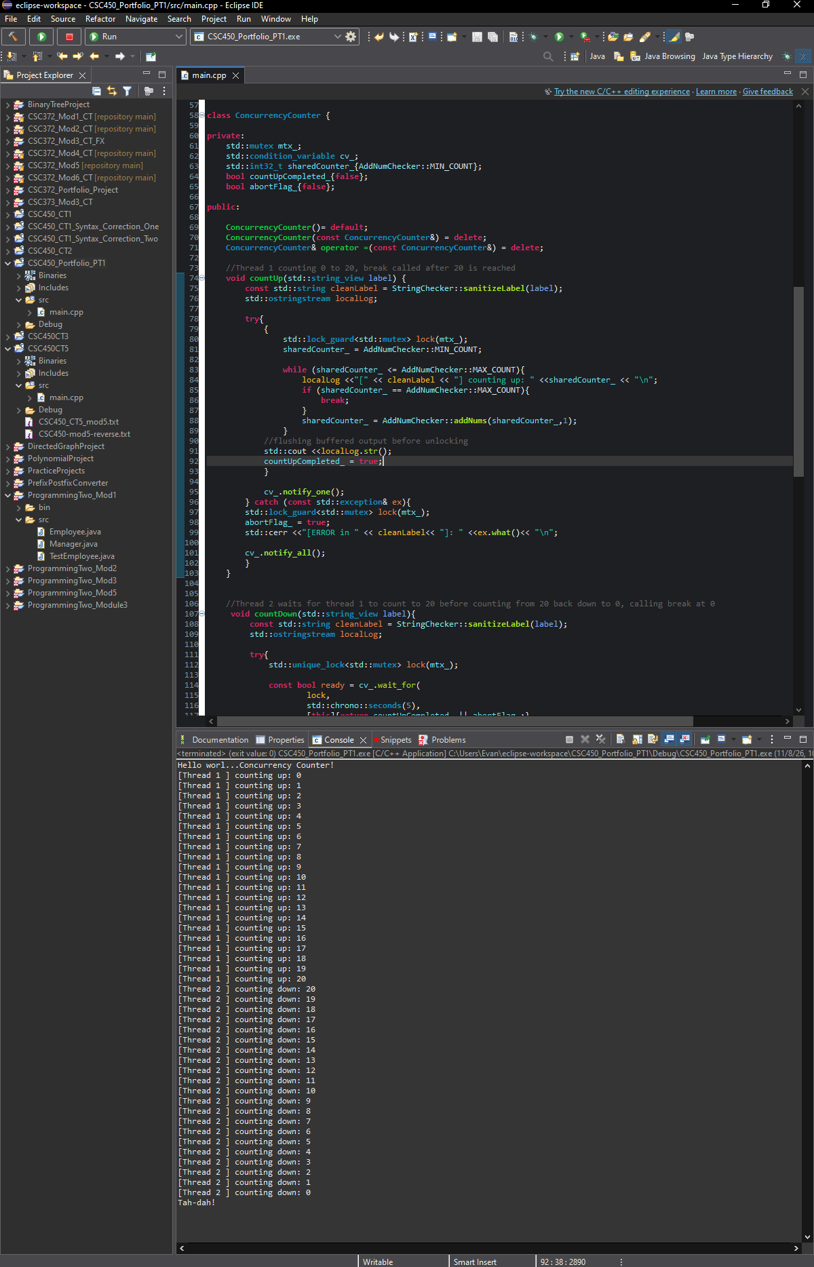

Section 4: Security Analysis
In using multithreading to run parallel workloads, and through the exploitable aspects of C++’s string handling, this program has several key layers of security to consider.

- Issues with Concurrency on Performance
  - Lock contention: in multithreaded programs, threads will typically acquire and release mutex on every loop and write it directly to std::cout. I/O is a slower system call, which means a thread holding mutex during cout would block other threads/cause lock contention. In this program, I had each thread write its output to ostringstream(localLog) and flush its completed buffer before releasing mutex. Considering the 40 numbers counted and mandatory swaps between threads, this takes 42 mutex acquisitions and reduces it to 2.
- String Vulnerability
  - Buffer Overflows: If an input string lacks a proper null terminator or is larger than an allocated fixed buffer size, buffer overflows can occur. To navigate this, I used string_view to use both a pointer and an explicitly fixed length in lieu of relying on null termination.
  - Memory Exhaustion: Given the thread labels in this program are repeated 21 times in each thread, passing an unbounded string could cause a crash. My StringChecker namespace’s sanitizeLabel() function prevents this by defining MAX_LABEL_LEN = 32, and allocating that capacity preemptively through clean.reserve(boundedLen).
- Data Type Security
  - Integer Sizing: With C++’s int type not having a universally defined bit width, I used AddNumChecker to define one. I used int32_t, which guarantees a 32-bit range. Using signed integers rather than unsigned ensures that when the counter gets to 0 and subtracts 1, it sees -1 as the result and stops. Unsigned integers, which use absolute value, would see 0 -1 and instead of moving into negatives, would roll back to the maximum allowable integer. This would cause an infinite loop.

Section 5: GIT repo
The repo for this project (CSC450 CT7) can be found here: https://github.com/ehofstadter/CSC450CT7

